**Ejercicio 9.3**

What does each removeMin call return within the following sequence of priority

queue ADT operations: insert(5, A), insert(4, B), insert(7, F), insert(1, D),

removeMin( ), insert(3, J), insert(6, L), removeMin( ),

removeMin( ), insert(8, G), removeMin( ), insert(2, H), removeMin( ),

removeMin( )?

|  |  |  |
| --- | --- | --- |
| **Método** | **Return Value** | **Priority Queue** |
| Insert (5, A) |  | {(5, A)} |
| Insert (4, B) |  | {(4, B), (5, A)} |
| Insert (7, F) |  | {(4, B), (5, A), (7, F)} |
| Insert (1, D) |  | {(1, D), (4, B), (5, A), (7, F)} |
| Remove Min () | (1, D) | {(4, B), (5, A), (7, F)} |
| Insert (3, J) |  | {(3, J), (4, B), (5, A), (7, F)} |
| Insert (6, L) |  | {(3, J), (4, B), (5, A), (6, L), (7, F)} |
| Remove Min () | (3, J) | {(4, B), (5, A), (6, L), (7, F)} |
| Remove Min () | (4, B) | {(5, A), (6, L), (7, F)} |
| Insert (8, G) |  | {(5, A), (6, L), (7, F), (8, G)} |
| Remove Min () | (5, A) | {(6, L), (7, F), (8, G)} |
| Insert (2, H) |  | {(2, H), (6, L), (7, F), (8, G)} |
| Remove Min () | (2, H) | {(6, L), (7, F), (8, G)} |
| Remove Min () | (6, L) | {(7, F), (8, G)} |

**Ejercicio 9.7**

Illustrate the execution of the selection-sort algorithm on the following input sequence: (22, 15, 36, 44, 10, 3, 9, 13, 29, 25).

|  |  |  |  |  |  |  |  |  |  |
| --- | --- | --- | --- | --- | --- | --- | --- | --- | --- |
| 22 | 15 | 36 | 44 | 10 | 3 | 9 | 13 | 29 | 25 |
| 3 | 15 | 36 | 44 | 10 | 22 | 9 | 13 | 29 | 25 |
| 3 | 9 | 36 | 44 | 10 | 22 | 15 | 13 | 29 | 25 |
| 3 | 9 | 10 | 44 | 36 | 22 | 15 | 13 | 29 | 25 |
| 3 | 9 | 10 | 13 | 36 | 22 | 15 | 44 | 29 | 25 |
| 3 | 9 | 10 | 13 | 15 | 22 | 36 | 44 | 29 | 25 |
| 3 | 9 | 10 | 13 | 15 | 22 | 25 | 44 | 29 | 36 |
| 3 | 9 | 10 | 13 | 15 | 22 | 25 | 29 | 44 | 36 |
| 3 | 9 | 10 | 13 | 15 | 22 | 25 | 29 | 36 | 44 |

**Ejercicio 9.22**

Illustrate all the steps of the adaptable priority queue call replace Key (e, 18) for

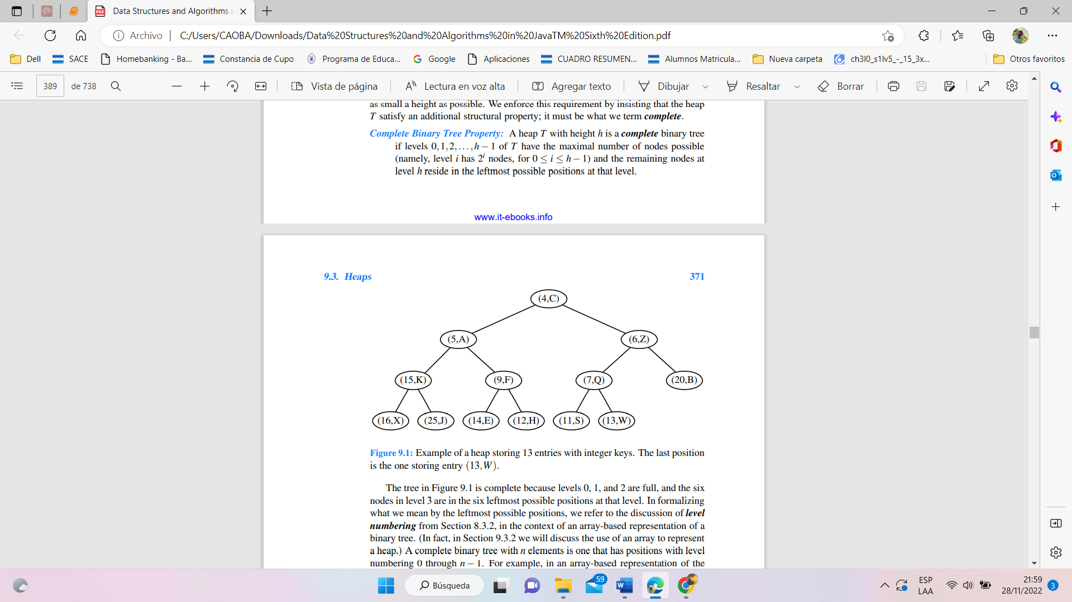entry e storing (5, A) in the heap of Figure 9.1.

**Nota:** Supongo que el ejercicio tiene un error porque 2 datos tienen la misma letra.